**Fundamentals of architectural working drawing: A Literature Review**

Arc 862 – Working Drawings and Specification Writing

Course Lecturers: Dr A.B. Sholanke, Dr B.A. Adewale

**Oyeyipo Funmilola Josephine (21PCA02242)**

College of Environmental Science, Department of Architecture, Covenant University, Ota, Ogun State, Nigeria

Email: [funmilola.oyeyipopgs@stu.cu.edu.ng](mailto:funmilola.oyeyipopgs@stu.cu.edu.ng)

April, 2023.

## *Abstract*

*An architectural working drawing is an essential aspect of the design and construction process for building projects, providing detailed instructions and specifications to contractors and builders to ensure accurate and efficient execution of the intended design. This study aimed to explore the fundamentals of architectural working drawing, including its history, key elements, importance, purpose, types, best practices, challenges, and opportunities. The systematic literature review method was employed for this research study, with a comprehensive search conducted using electronic databases such as Scopus, Web of Science, and Google Scholar. Articles and journals published in English between 2002 and 2023, focusing on the fundamentals of an architectural working drawing, were screened based on predefined inclusion and exclusion criteria. The review identified the importance of an architectural working drawing in construction projects, the evolution of its use from ancient times to the present, the several types of architectural working drawings, and the best practices for creating effective and efficient drawings. It also identified the challenges and opportunities in the field, including the lack of standardization and attention to quality and the potential of digital technology to improve the quality and efficiency of an architectural working drawing. Based on the review, it is recommended that industry stakeholders prioritize standardization and quality in an architectural working drawing, with a focus on the adoption of digital technology to improve efficiency and accuracy. Further research is also recommended to explore the potential of emerging technologies such as artificial intelligence and virtual reality in an architectural working drawing. The study is valuable as a reference for scholars to review and improve on.*

**Keywords:** Architectural Working Drawing, Working Drawing Types, Working Drawing Elements, Building Plans, Working Drawing Review, working drawing fundamentals, Construction Documentation.

# 1. Introduction

The use of drawings in architecture dates to ancient times when drawings served as a means of communication between builders and architects. In the 15th century, the use of perspective and orthographic projections revolutionized architectural drawing, leading to more accurate and detailed representations of buildings. With the advent of digital technology in the 20th century, the process of creating architectural drawings became more efficient, accurate, and accessible. Architectural working drawing has a rich history that dates to ancient times. According to Ching (2014), ancient Egyptians, Greeks, and Romans used drawings as a means of communication between builders and architects. In these early civilizations, architectural drawings were used to communicate design ideas and specifications, such as building materials, construction techniques, and dimensions. These early drawings were typically created using basic tools such as pen and ink, and parchment paper. In the 15th century, the use of perspective and orthographic projections revolutionized architectural drawing, leading to more accurate and detailed representations of buildings (Ching, 2014).

This innovation enabled architects to create more complex designs and communicate their ideas more effectively. During this period, the development of printing technology also enabled the mass production and distribution of architectural drawings. With the advent of digital technology in the 20th century, the process of creating architectural drawings became more efficient, accurate, and accessible (Lin and Chang, 2010). According to Kim and Choi (2015), the use of computer-aided design (CAD) software has become widespread in architectural design and drawing, allowing architects and designers to create complex designs, manipulate them easily, and produce high-quality drawings quickly. The use of 3D printing technology has also enabled the creation of physical models from digital drawings, further improving the accuracy and efficiency of the drawing process. In summary, the history of architectural working drawing has seen significant advancements in terms of tools and techniques used, from basic pen and ink drawings in ancient times to digital technology in modern times.

These advancements have enabled architects to communicate their ideas more effectively, create more complex designs, and produce high-quality drawings quickly and accurately. Architectural working drawings were utilized for the construction of churches and cathedrals during the Middle Ages, with expert masons developing precise blueprints for the buildings and their many aspects (Jones, 2005). Architects such as Leonardo da Vinci and Andrea Palladio created new techniques and styles for architectural drawing throughout the Renaissance period, with Palladio's work focusing on proportion and symmetry in design, expressed through meticulous drawings and engravings. The industrialization of architectural drawing began in the nineteenth century, with the introduction of new tools and technology such as T-squares, set squares, and drawing boards (Lee, 2012). This made it easier to produce accurate and detailed drawings, while the development of new architectural styles such as the Gothic Revival and Art Nouveau led to new drawing techniques and styles. The 20th century marked a significant shift in the way architects and designers create and communicate their designs, with the advent of computer-aided design (CAD) (Johnson, 2016).

This technology revolutionized the process of creating architectural working drawings, making it faster and more accurate. Today, architectural working drawings are created using a combination of traditional drawing techniques and computer-aided design software. Therefore, the history of architectural working drawing dates to ancient times when architects and builders used drawings to communicate their designs. An architectural working drawing is a critical aspect of the design and construction process for building projects. The drawings provide a clear and accurate representation of the building design by containing detailed information on the materials, dimensions, and construction techniques required to execute the intended design accurately. These drawings serve as a communication tool between architects, engineers, and contractors, ensuring that everyone involved in the project is on the same page. Over time, the process of creating architectural working drawings evolved, and with the advent of computer-aided design (CAD) software, the creation and utilization of architectural working drawings have become more efficient and accurate.

Accurate architectural working drawing helps to minimize errors and reduce construction time and costs (Brahmi & Sidawi, 2017). It provides detailed instructions and specifications to contractors and builders to ensure that the intended design is accurately and efficiently executed. Despite the importance of architectural working drawings, its diligent development is often overlooked and not given the necessary attention, leading to errors, delays, and cost overruns in the construction process. The construction industry is known for its complexity, and architectural working drawing serves as a bridge between design and construction. Furthermore, the importance of architectural working drawing cannot be overstated, as it forms the foundation of the entire construction process. The architectural working drawing is a design information source that communicates the architect's design intent to the construction team, including builders, engineers, and contractors and serves as a reference document throughout the project's life cycle. Thus, any mistakes or oversights in the working drawing can have severe consequences. It is important to note that the creation of accurate and detailed architectural working drawings can be challenging due to several factors.

These include the complexity of modern building designs, changes in project scope or requirements, and the need to integrate various systems and components. Standardization of architectural working drawings has been critical to ensure that designs are communicated effectively, and construction requirements are met. According to the AIA, the use of standardized symbols and conventions in architectural working drawings promotes clarity and consistency in communication between different stakeholders (AIA, 2007). Working drawings have experienced several adjustments and refinements in recent years as a result of diverse economic, social, and technical advances. Working drawings have increased in number and information content due to the continual development of new construction materials and processes, as well as breakthroughs in the building sciences. In addition to the requirements of building codes and zoning regulations, the fear of litigation burdened the drawings with layer after layer of often useless information, making them so complex that a constant demand for interpretation by those attempting to read the drawing (Omar, 1991).

Standardization also guarantees that designs are simple to read and comprehend, lowering the chances of misunderstanding and mistakes during construction. Several organizations have produced industry guidelines and standards to ensure standardization in architectural working drawings. The National Institute of Building Sciences (NIBS) has issued the United States National CAD Standard (NCS), which provides a complete set of rules and procedures for the creation and exchange of CAD drawings in the industry (NIBS, 2021). Similarly, the AIA has released Architectural Graphic Standards (AGS), a thorough reference to drafting norms and standards used in architectural working drawings (AIA, 2007).. However, the lack of awareness and adoption of standardization and clear guidelines in architectural working drawings led to inconsistencies and further compounded these challenges. Also, the use of CAD software has also introduced new challenges in the field of architectural working drawings, such as the need for specialized training and the potential for errors in the software. These are the gap this study wasset to fill. Therefore, this review paper aimed to highlight the critical role of architectural working drawing in the construction process and provide a basis for future research in the field. By establishing a clear understanding of its fundamentals and addressing its challenges and opportunities in the field of architectural working drawing, providing valuable insights into potential avenues for future research, this review also aimed to improve the accuracy, efficiency, and success of construction projects worldwide. Exploring its history, purpose, types, and best practices, this review provided insights into the creation and utilization of architectural working drawing in the modern construction industry. The next sections provided an in-depth analysis of the literature on architectural working drawings. The study addressed the gap in knowledge by providing a comprehensive overview of the fundamentals of architectural working drawing. Specifically, the review will explore the following research questions:

1. What are the importance and key purposes/uses of an architectural working drawing?
2. What are the types and standard requirements of key architectural working drawings?
3. What are the key concepts and principles of an architectural working drawing?
4. What are the tools and techniques for an architectural working drawing?
5. What are the standard symbols, abbreviations, and symbols application in an architectural working drawing?
6. What are the challenges, limitations, and opportunities of architectural working drawings?
7. What are the best practices in architectural working drawing?

To provide suitable answers to the research questions, six (6) two objectives were established.

1. Identify the importance and key purposes/uses of an architectural working drawing.
2. Identify types and standard requirements of key architectural working drawings.
3. Identify key concepts and principles of an architectural working drawing.
4. Identify tools and techniques for an architectural working drawing.
5. Identify the standard symbols, abbreviations, and symbols application in an architectural working drawing.
6. Identify the challenges, limitations, and opportunities of architectural working drawings.
7. Identify the best practices for an architectural working drawing.

The systematic literature review findings were be presented in a narrative style, including a summary of the important findings. The findings were be provided in answer to the above-mentioned research questions. The study also included a discussion of the field's difficulties and prospects, as well as prospective future research directions. This literature evaluation will be useful to architects, engineers, contractors, and anybody else engaged in the design and construction of building projects.

# 2. Methodology

This research study used the qualitative research approach. The systematic literature review strategy is a way of evaluating and analyzing current literature on a certain issue that is organized and complete. The systematic literature review method is widely acknowledged as an efficient way for identifying and synthesizing current research on a certain issue. A systematic review, according to Khan et al. (2020), is a comprehensive and thorough strategy for identifying and evaluating all relevant papers on a certain issue. The implementation of this method assures that the review is transparent, reproducible, and trustworthy, and it reduces the chance of bias or mistakes in the literature selection and synthesis. Therefore, a comprehensive search for conference proceedings, journals and grey literature were conducted using electronic databases such as Scopus, Web of Science, and Google Scholar.

These online databases were chosen because they have been evaluated and proven to be reputable research sources for vital academic information. Using a combination of keywords such as “architectural working drawing”, “working drawing types”, “working drawing elements”, “building plans”, “working drawing review”, “working drawing fundamentals”, and “construction documentation”, the search was limited to articles and journals published in English between 2002 and 2023, with a focus on those that examined the fundamentals of architectural working drawing. The use of keywords was to ensure a comprehensive and focused search. The articles, grey literature and journals were screened based on predefined inclusion and exclusion criteria, and data were extracted and synthesized using a standardized form.

The search strategy was refined through the screening of the titles and abstracts of retrieved articles and journals, and those that did not meet the inclusion criteria was excluded. The inclusion criteria for this study were articles and journals that focused on the fundamentals of architectural working drawing. The exclusion criteria were articles and journals that were not relevant to the study, such as those that focused on other aspects of architecture or engineering that were not related to working drawings. This method ensures that all relevant literature on the topic is identified, critically evaluated, and synthesized to provide a comprehensive overview of the topic. The following steps were taken to conduct this systematic literature review: i. identification of the research question which guided the literature review process, ii. Identification of relevant literature, iii. screening and selection of studies, iv. data extraction using a standardized form that included study characteristics, addressing research questions, methodology, key findings, and limitations, v. data synthesisation using a narrative approach that included a thematic analysis of the findings, vi. data analysis using a qualitative approach to identify themes and patterns in the literature, vi. Presentation of findings and discussions, and vii. Conclusion and recommendation.

Finally, the quality of the selected articles and journals was assessed using the Critical Appraisal Skills Programme (CASP) tool, which is a validated tool for assessing the quality of research studies. The use of this tool enabled the researchers to evaluate the validity, reliability, and applicability of the selected articles and journals and to identify potential biases or limitations in the research. Findings from the literature reviewed were presented in text, figures, and tables.

# 3. Result and discussion

This section would contain the following parts, i. Summary of the crucial information identified from existing works of literature, ii. Comparison of the findings with previous research in the field and iii. Discussion of the results in relation to the research questions and objectives. Under this section, the subdivision of working drawings would be explained, they include the following.

1. Location Drawings - These are created to depict the overall composition of the project. A location drawing will include specifics for all of the project's sections and structures provided they are to be built. Floor plans, elevations, projections, alternative plans, and sections are all included. They are sometimes referred to as general arrangement drawings. They indicate the location of the construction sections (United,2023).
2. Assembly Drawings - These drawings are used to show the connection between two structural components. It demonstrates how the many components of the building fit together. It features a wide range of patterns and designs, including 3D, sectional, and elevation views. Wall details, for example, illustrate the layers that make up the building and how they are attached to structural parts.
3. Component Drawings - Component drawings are typically drawings given by a product's maker. These designs are complete with part drawings, offering a full understanding of its markings and many sub-parts of a component. They allow for the fabrication of self-contained pieces, such as windows and door sets, in a workshop and then sent to the site complete and prepared for installation.(United,2023).

## 3.1 Importance and Purpose/Uses of an Architectural Working Drawing

An architectural working drawing plays a significant role in the construction industry by providing complete documentation of the designer's goals, that is, a clear, and accurate representation of the building design. They are graphical representations developed before the construction process that contains detailed dimensions, depths, layouts, and important notes of what will be created and how it would be realized on site. In a project, there is an architectural working drawing allocated to the components of a building project e.g., walls, floors and roofs that illustrates the complexities of each. Architectural working drawings are blueprint construction drawings made meticulously to scale to enable engineers and contractors in visualizing the project. These Accurately articulated and comprehensible drawings serve as a communication tool between architects, engineers, and contractors, ensuring that everyone involved in the project is on the same page. Therefore, it must be Detailed enough for its intended use,  contain the correct information, and must be readily obtainable from the sheer amount of other information with which it will unavoidably be mixed.

The drawing is useful as a Blueprint for gaining statutory approval, a Construction Guide on-site, a contract document, or basis for tendering, a model for creating a construction program, base data for the creation of further construction documents, a framework for selecting nominated suppliers or subcontractors, a source for making shop drawings, an inventory for procuring material, a document for project supervision, a record of modifications from the contract, a record of the completed construction, producing as-built drawings, a base document for defects liability inspection, base document for measurement of the completed works, for the preparation of final accounts, and as an assessment/feedback source. An accurate architectural working drawing helps to minimize errors and reduce construction time and costs (Brahmi & Sidawi, 2017). Architectural working drawings are critical in conveying the design intent of a building project to contractors and builders. They provide detailed instructions and specifications to ensure that the intended design is accurately and efficiently executed. As noted by Leach et al. (2018), the purpose of working drawings is to represent design information in a comprehensive and precise manner that can be interpreted and used by contractors and builders during construction.

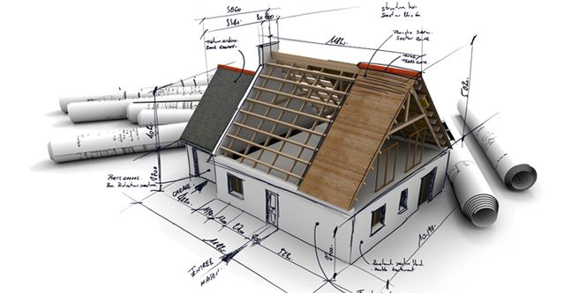

**Fig 1:** Shows the relationship between an architectural working drawing and a building project.

Furthermore, architectural working drawings are crucial in specifying construction details, such as materials, dimensions, and tolerances, and providing a basis for the construction coordination process. The importance of high-quality working drawings cannot be overemphasized as they play a critical role in ensuring the construction process's efficiency, cost, and quality (Leach et al., 2018; Reddy et al., 2016). Reddy et al. (2016) emphasized that the primary purpose of architectural working drawings is to translate the design concept into a set of detailed, comprehensive, and precise instructions that guide the construction process. They further noted that working drawings help to ensure that the building is constructed according to the design intent and that the different components of the building are coordinated correctly. Similarly, Leach et al. (2018) highlighted the importance of clear and accurate working drawings in preventing design errors, reducing the need for redesigns, and minimizing the risk of costly construction delays and disputes. Finally, architectural working drawings serve multiple purposes in the construction process, including communicating design intent, specifying construction details, and facilitating construction coordination. The quality of working drawings has a significant impact on the efficiency, cost, and quality of the construction process. Therefore, it is crucial to ensure that architectural working drawings are of high quality and accurately represent the design intent.

## 3.2 Types and Standard Requirements of Key Architectural Working Drawings.

There are diverse types of architectural working drawings, each serving a specific purpose in the construction process. These include floor plans, reflected ceiling plans, roof plans, exterior elevations, interior elevations, sections, details, site plans and schedule of drawings. (Kumar et al., 2019). According to Wong and Wong (2014), architectural working drawings can further be categorized into diverse types based on their purpose, scale, and level of detail. Floor plans are a type of architectural working drawing that provides a bird's eye view of the building's layout and are used to show the overall arrangement of spaces within the building. Elevations, on the other hand, provide a vertical view of the building's exterior and are used to show the building's proportions, style, and features.

Sections are drawings that cut through the building to show the relationship between interior spaces and building components, such as walls, ceilings, and floors. Details are drawings that show specific building components in more detail, such as windows, doors, and stairs. Schedules are used to list the types and quantities of building materials required for construction, while specifications outline the materials and methods to be used in construction (Wong & Wong, 2014). Additionally, Tachie et al. (2016) identified site plans, landscape plans, and interior design plans as other types of architectural working drawings that are used to communicate design intent and construction details. The diverse types of architectural working drawings play a critical role in the construction process and are essential for ensuring that the intended design is accurately executed. In a working drawing layout, attention should be paid to the dimension, font style and size.

Dimension lines are drawn in lighter lines and as a continuous group or string of numbers along a line. Arrows, dots, or 45-degree tick marks are used at the junction of the extension and dimension lines. A thicker and/or darker line is used to make the arrows, dots, or check marks stand out visually. The tick marks at 45 degrees are produced in a straight line.. Attached to all architectural working drawings is a checklist. The drawing checklist contains a list of the basic or standard requirements of the drawing to ensure accuracy and completeness. The title block checklist is a general checklist of all architectural working drawings that gives validity and identity to the drawings. It includes the architect’s firm, name, email, address and contacts, client’s name, project name and address, drawing title, project number, project status, project team details, drawing scale, drawing date, sheet size, drawing number, revision bar, drawing notes, key plan, north point, and legend (Ige, 2018). The following are the broad types and checklists of architectural working drawings based on their different purpose, scale, and level of detail.

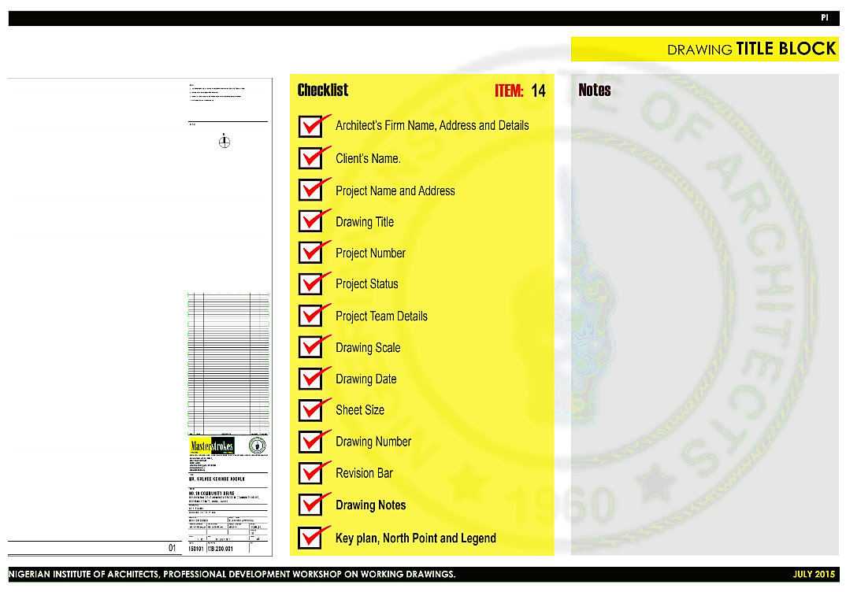

Source: Arc Sola Ige – NIA Professional Development Workshop on Working Drawings (2015).

**Fig 2:** Example of a title block checklist for an architectural working drawing.

**3.2.1 Site plans**

Site plans are two-dimensional or three-dimensional drawings that indicate the position of a structure or project on a site, including features such as parking, landscaping, and utilities. Site plan standardization contains criteria for symbol positioning, text arrangement, and dimensioning, which ensure uniformity and clarity in the portrayal of site plans. ANSI and ISO govern the standardization of site plans. A site plan is included in the architectural working drawing.

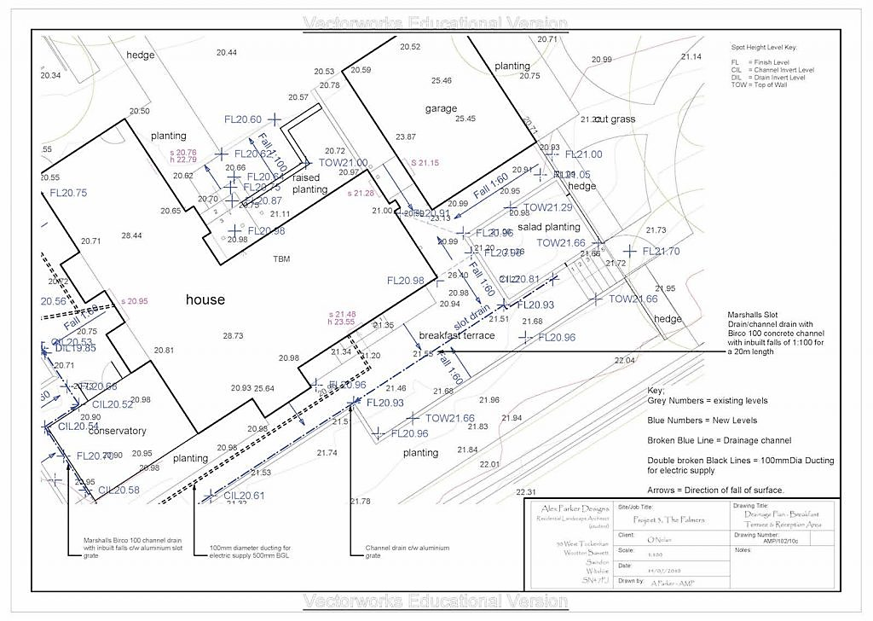

Source: <https://happho.com/working-drawings-required-for-house-construction-project/>

**Fig 3:** Example of an architectural working drawing site plan.

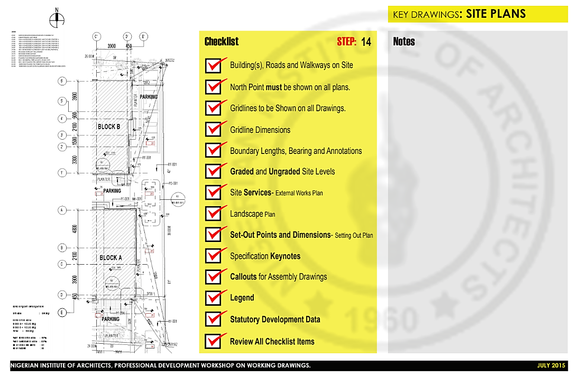

Source: Arc Sola Ige – NIA Professional Development Workshop on Working Drawings (2015).

**Fig 4:** Example of a title block checklist for an architectural working drawing.

It serves as a map of your construction site and contains information on how the structure will be orientated. Site plans are large-scale dimensioned and extensively labelled drawings that show the site boundaries, building boundaries, building distance from boundary lines, and overall site extent for a proposed or existing development. (BluEntCAD, 2021). They are required for planning applications, along with location plans. They are supplemented by site sections that depict the geography of the place. Site plan drawings are typically prepared following a series of site surveys and desk research. Depending on the magnitude of the project, they may be at a scale of 1:200 or 1:500. Larger sizes, on the other hand, are employed for major tasks. (BluEntCAD, 2021).

**3.2.2 Floor plans**

Floor plans are top-down drawings with 2D dimensions and comprehensive labelling that illustrate the arrangement of a building's rooms, walls, doors, windows, and other elements. The American National Standards Institute (ANSI) and the International Organization for Standardization (ISO) are principally in charge of floor plan standardization. They provide measurements, symbols, and text layouts to maintain uniformity in floor plan depiction. Many special symbols are used on the floor plan. Columns, for example, are frequently assigned a grid number and dimensioned with reference to the column centerline.

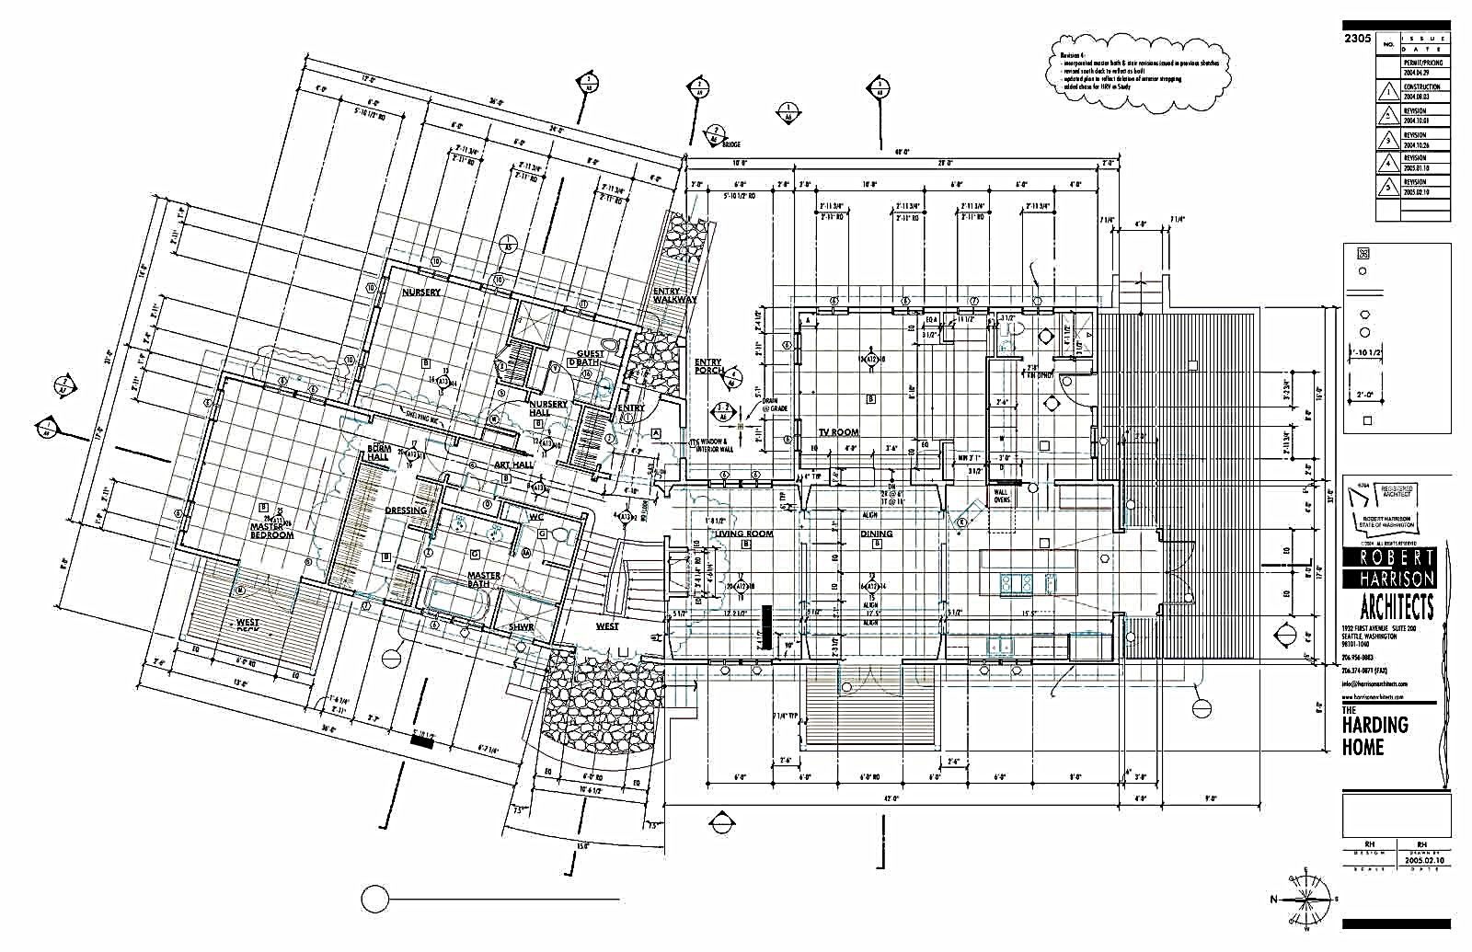

Source:

**Fig 5:** Example of a working drawing floor plan.

Once more, a circle with numbers and an arrow pointing in the direction of view are employed. To make it simple for the observer to discern between sections and elevations, some designers like to create a clear visual distinction between the two. For instance, the arrow in is only darkened in on sections and not on heights. Before a floor plan can be completed, several considerations must be taken. The designer will spend the most time developing the floor layout. Drafting floor designs in a logical order is more successful; that is, start with the flooring, walls, openings, door swings, fixtures, and cabinets; then add dimensions, symbols, and any pertinent comments.

A floor plan is precisely dimensioned to ensure that walls, columns, doors, windows, openings, stairs, and other details are correctly positioned for construction. When a plan is properly scaled, its replication may result in a modest expansion or reduction in the drawing. The floor layout is from the real scale in such circumstances, but this is fine because the printed measurements are the regulating parameters. Most designers, in fact, include a notation, "Do not scale drawing, follow written dimensions."

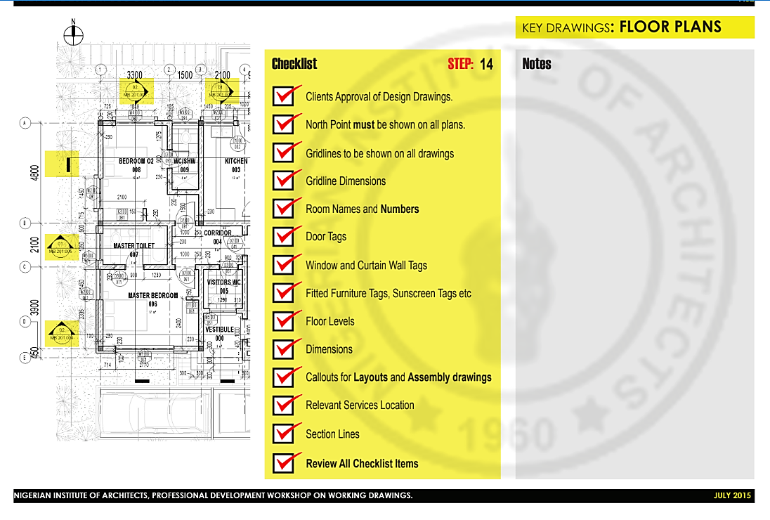

Source: Arc Sola Ige – NIA Professional Development Workshop on Working Drawings (2015).

**Fig 6:** Example of a floor plan checklist for an architectural working drawing.

To make it simple to locate a certain column, the grid has letters of the alphabet and numbers along one or both axes. The end of this line has a bubble for the column designation that is proportioned to the relevant wording within it. The reference line may, in some circumstances, be at the face of a column rather than its center, such as at an end column. The size of the rooms will be determined by other specifications included in the design, which also specify the precise location of the studs. The room's dimensions are shortened by the thickness of the finishes that are applied over the studs.

**3.2.3 Reflected Ceiling Plan.**

A reflected ceiling plan (RCP) contains information that is required by construction professionals in the construction process, from interior designers and architects to electricians and plumbers. This section of the dimensioned and labelled ceiling design contains critical information concerning light fixtures and lighting plans, HVAC mounts, sprinklers, smoke detectors, any equipment that requires specific venting, and any other mechanical or electrical object on the ceiling. (Edraw Content Team, n.d.; Hesson, 2023). The primary purpose of an RCP in a set of plans is to show the interior designer or architect how lighting works in the room. However, an architect or engineer must first determine the ceiling-to-floor balance and include those proportions in the layout. These dimensions will include the ceiling height as well as the slope or slant over the project, as well as features such as vaults or decorations, and the amount of insulation.

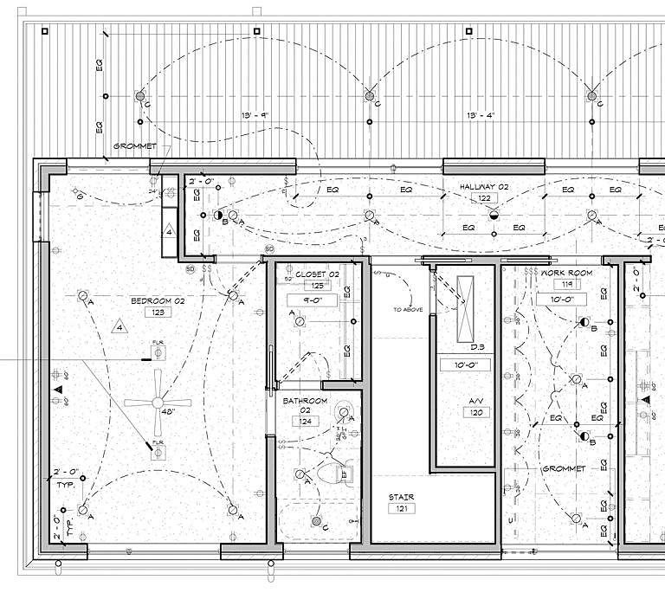

Source: Bob Borson (2017)

**Fig 7:** Example of an architectural working drawing Reflected ceiling plans.

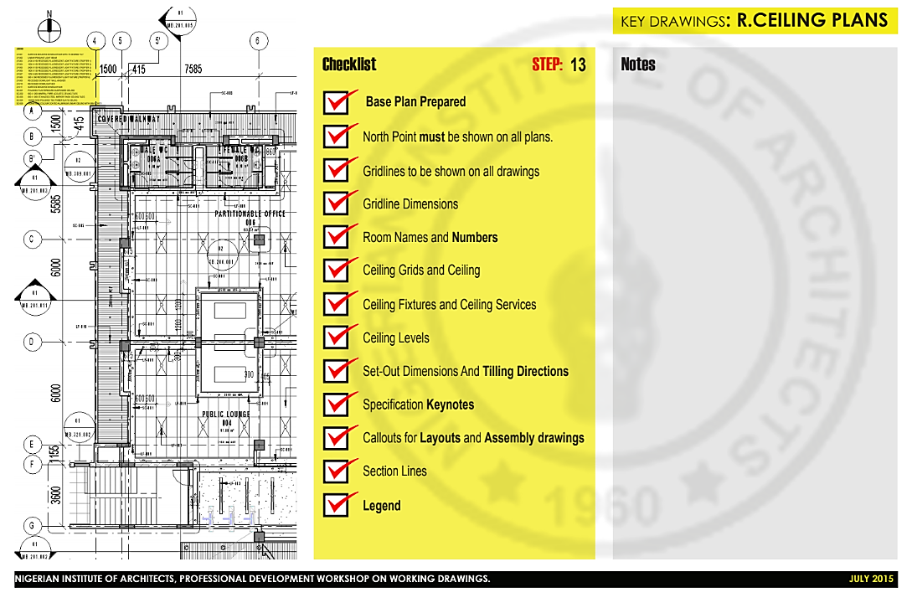

Source: Arc Sola Ige – NIA Professional Development Workshop on Working Drawings (2015).

**Fig 8:** Example of a reflected ceiling plans checklist for an architectural working drawing.

The ceiling is one of the most useful features of a room since it supports many components. (Hesson, 2023; Mahgoub, 2020; Smith, 2020). To conceal wiring and circuits, a suspended system creates a gap between the ceiling and the flooring above it (or the roof). A ceiling may also include an exposed system, such as wooden beams, to support the panels that conceal the numerous service components. When an architect or interior designer examines the RCP, they can see the structural arrangement of the space and add the lighting needs for each area. (Vasquez, 2022). They will examine the electrical blueprints to determine the requirements, which will include dimmers, electrical and telecom connections, and panel boards. Reflected Ceiling Plans are used by architects to illustrate the materials, measurements, and other important information about the ceilings of all the rooms on the property layout. (Hesson, 2023; Vasquez, 2022; Mahgoub, 2020; Smith, 2020).

**3.2.4 Roof plans**

Detailed roof plans for working drawings would include a lot more information like the roof dimensions, specifications for roof pitch/slope, the placement of vents and drainage, material specifications, and ridge start and end points, it may also include framing details. A working drawing roof plan is a 2D framing architectural working drawing that depicts the roof features and dimensions from above. Designers may "validate" the roof using roof planning software by clicking a button and having the software evaluate the physics of the roof. Roof plans are used by designers, house builders, remodelers, and architects to verify that any roof they create is structurally solid. Roofing contractors and framers use roof blueprints to ensure that they build a roof to exact specifications. Roof designs are also used while remodeling an existing roof (Cedreo, 2022).

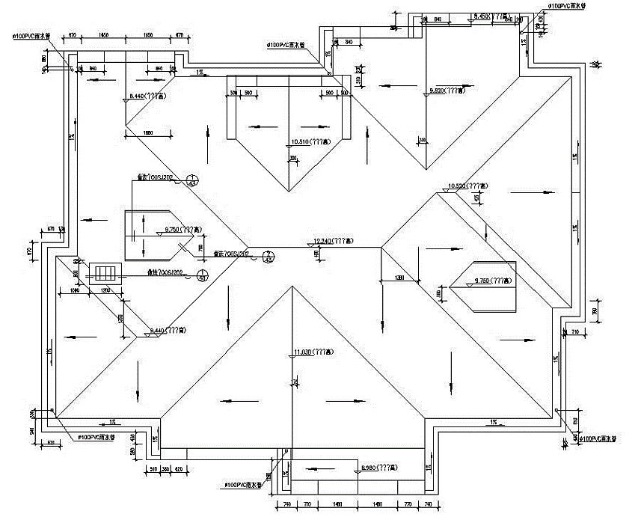

Source: https://cadbull.com/detail/144192/Roof-Plan-Working-Drawing-DWG-File

**Fig 9:** Example of a working drawing roof plan.

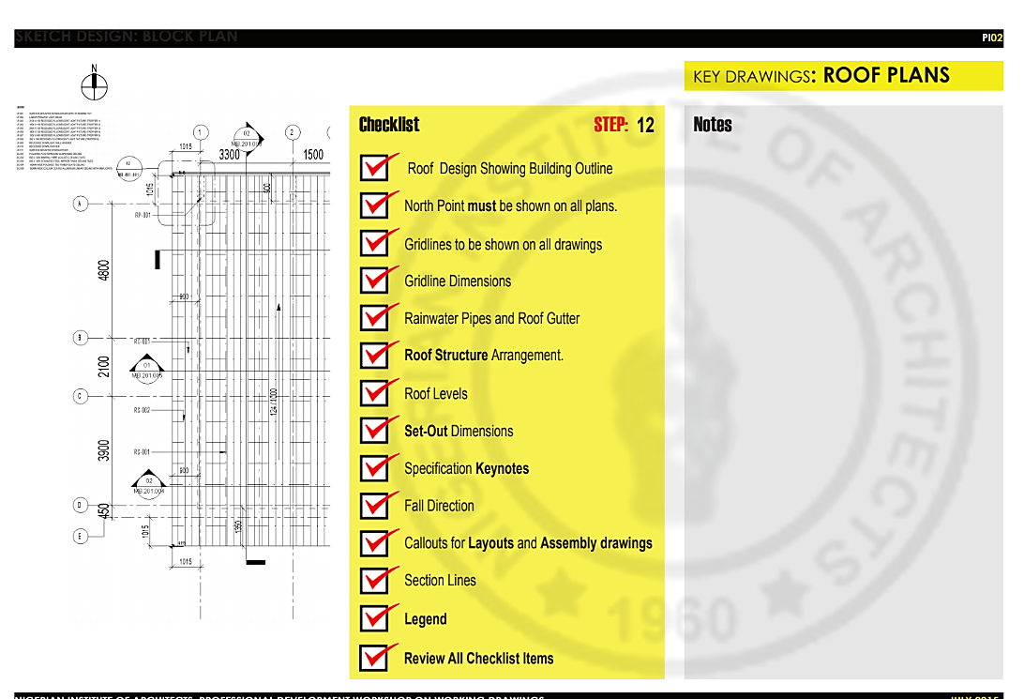

Source: Arc Sola Ige – NIA Professional Development Workshop on Working Drawings (2015).

**Fig 10:** Example of a roof plan checklist for an architectural working drawing.

**3.2.5 Exterior and Interior Elevations**

Elevations working drawings are dimensioned and labelled 2D architectural working drawings that depict the outside or interior walls of a structure from a straight-on perspective. Elevation standardization contains criteria for line weights, dimensions, and symbols that offer uniformity and clarity in elevation depiction. ANSI and ISO govern elevation standardization. An orthographic projection—a two-dimensional representation of a three-dimensional envelope—is what an external elevation working drawing is. The phrase 'elevation' in construction operations refers to an orthographic projection of a building's external or occasionally interior appearances, that is, a two-dimensional sketch of the building's façades. An elevation drawing is a first-angle projection that depicts all aspects of a structure as seen from a certain direction, with the perspective flattened.

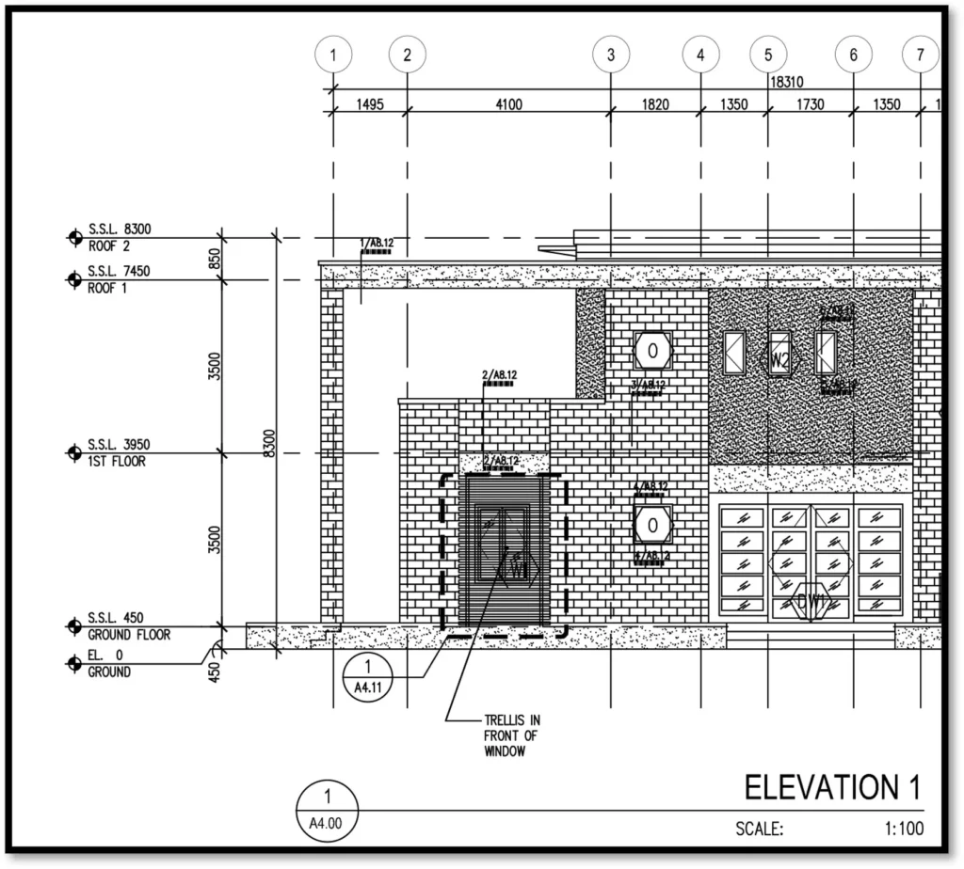

Source: https://archi-monarch.com/making-of-good-for-construction-drawing/

**Fig 11:** Example of an Exterior Elevations of an architectural working drawing.

Elevations are created for four directional perspectives, such as north, south, east, and west. Inadequate information on elevations might imply that they fail to meet the purpose for which they were created; nevertheless, extremely comprehensive altitudes can be time-consuming and expensive to create, as well as complicated to read. It is therefore critical that the rationale for the drawing is apparent and that the amount of information necessary meets that demand (Designing Buildings Wiki, 2023). The outside and interior elevations of a working drawing are generated for the following reasons: As part of an existing building survey, i. establish documentation of an existing building, ii. investigate and convey interior and exterior design alternatives, iii. as part of a planning permission implementation, iv. as part of a building regulations approval implementation, v. to convey construction information, vi. for tendering purposes (Designing Buildings Wiki, 2023).

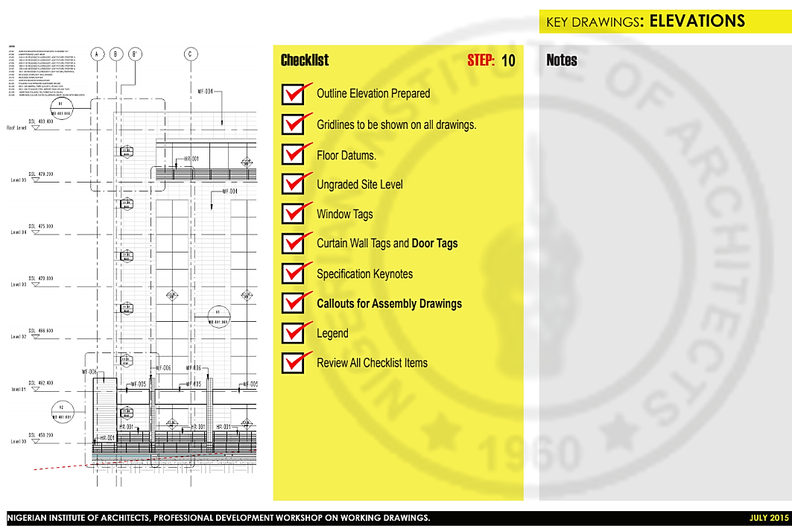

Source: Arc Sola Ige – NIA Professional Development Workshop on Working Drawings (2015).

**Fig 12:** Example of a title block checklist for an architectural working drawing.

Both commercial and residential working drawings of an elevation is useful for to achieve the desired environment. Working drawing interior elevations contains measurements and comprehensive labelling to assist figure out where to arrange objects and other features inside a particular area is part of the design planning phase, which may help a designer envisage commercial building designs or residential plans. The internal elevation is a two-dimensional illustration with varied degrees of detail of a wall (or sequence of walls). An interior working drawing elevation provides the designer with a front or side perspective of a space, increasing in complexity and details such as where appliances or built-ins should be placed are included during the project. (MasterClass, 2022).

A working drawing elevation is ideal for examining finer detailed features from eye level, making it particularly beneficial for kitchen, toilet, bedroom design and other forms of refurbishment. With an elevation, you can see specifics like where appliances would be placed and how your furniture will move (for example, the way the doors on your cabinets swing or how far a drawer will pull out). While a floor plan provides a broad outline of the room design, an elevation drawing takes the professionals inside the space and allows them to get a more detailed representation of how it will look when finished. A working drawing interior or exterior elevation aids in as built funiture and material placement planning throughout the design and construction processes of a project.

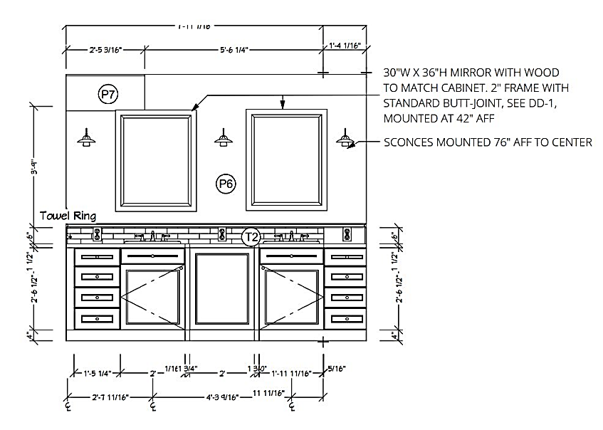

Source: https://www.outsourcingcadworks.com/interior-elevations/

**Fig 13:** Example of an interior elevation of an architectural working drawing.

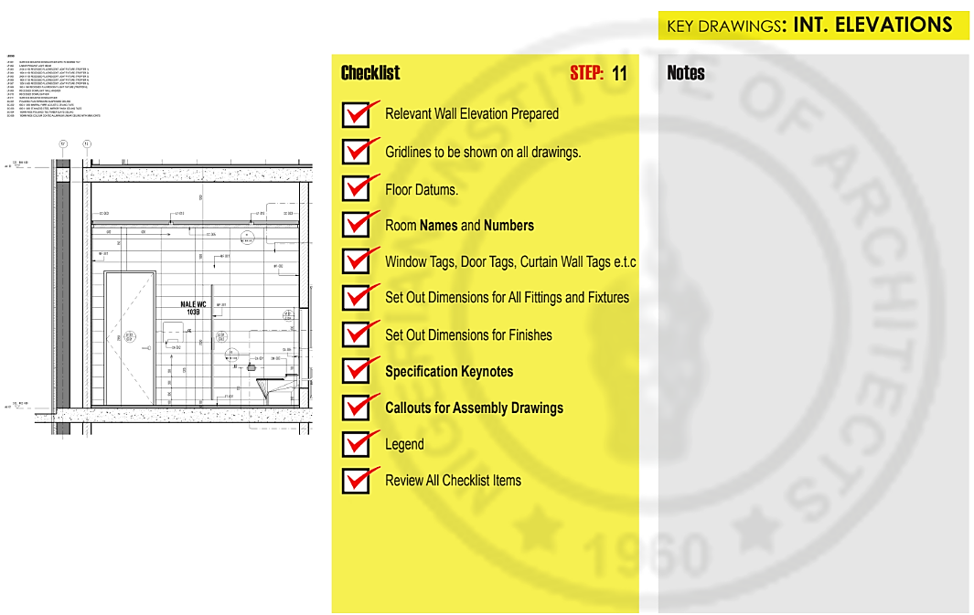

Source: Arc Sola Ige – NIA Professional Development Workshop on Working Drawings (2015).

**Fig 14:** Example of an interior elevation checklist for an architectural working drawing.

**3.2.6 Section and Detail Drawings**

Sections are dimensioned and thoroughly labelled 2D drawings that illustrate a cut through a building to display the internal intricacies of walls, floors, and other elements. Guidelines for line weights, dimensions, and symbols are part of the standardization for sections, which provide uniformity and clarity in the portrayal of sections. Standards for sections are set by ANSI and ISO. Section are limited when it comes to showing tiny features of a component, therefore, specific architectural elements or construction features, such as windows, doors, staircases, or framework, are described in a separate sheet known as detail. Additionally, the size of the floor plan makes it impossible to include all of the required information or comments in confined spaces like stairwells and restrooms. In these situations, an extended map of the locations is created elsewhere and cross-referenced on the map.

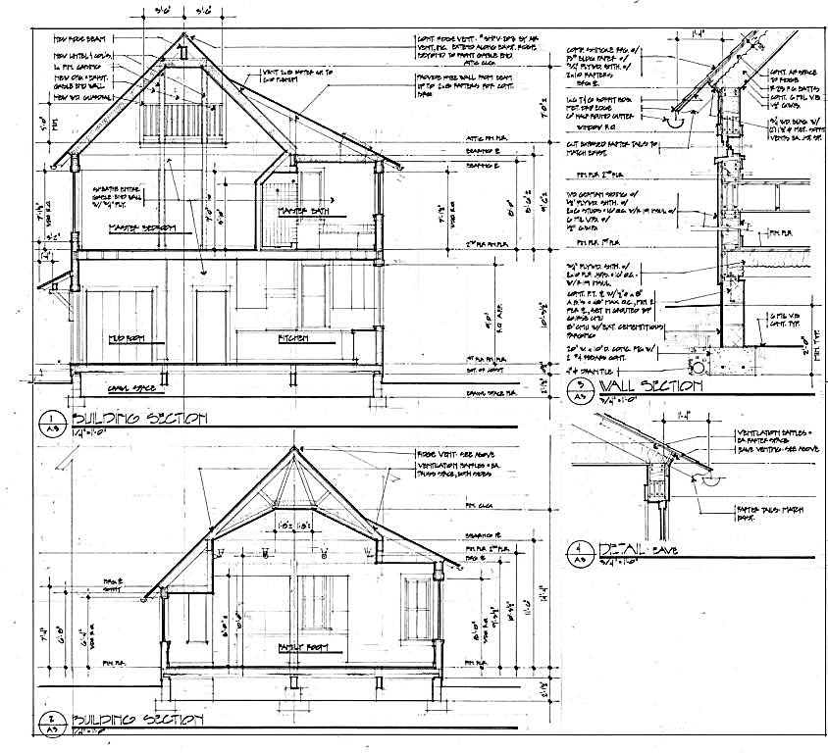

Source: https://happho.com/working-drawings-required-for-house-construction-project/

**Fig. 15:** Example of a section of an architectural working drawing.

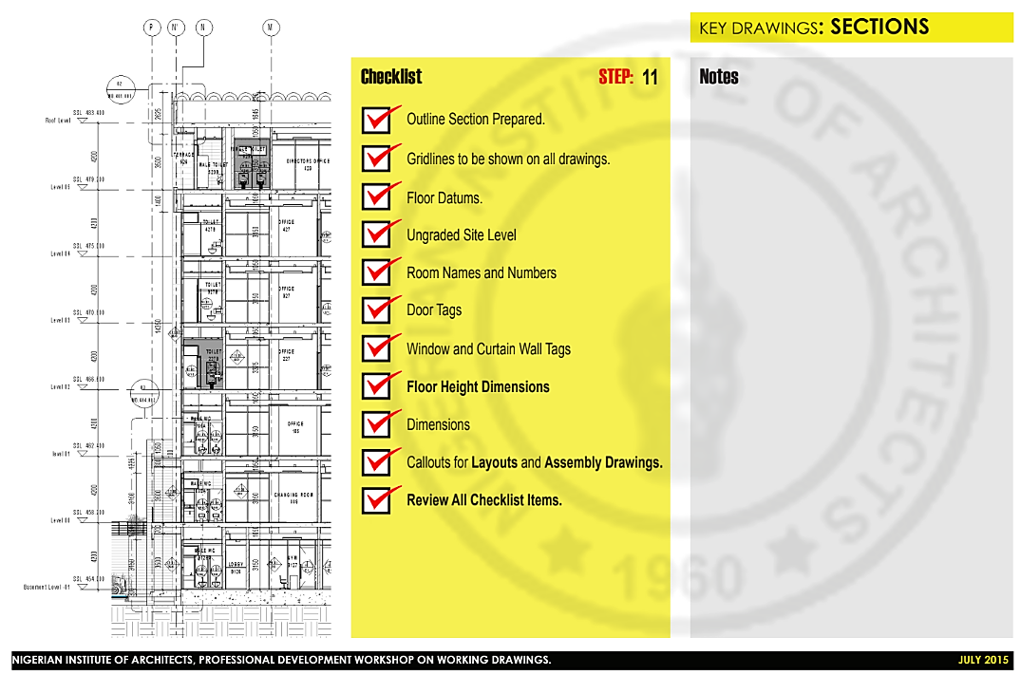

Source: Arc Sola Ige – NIA Professional Development Workshop on Working Drawings (2015).

**Fig 16:** Example of a section checklist for an architectural working drawing.

The only indication that the zone has been increased could be a callout symbol. Strong broken lines are used as callout signs to mark the area that needs to be extended. It is symbolized by a circle and a number(s), just like the section or elevation sign. The floor-plan page or another sheet may include this bigger plan. The same method may be used to provide specifics on other qualities, like a column or assembly. Sections are drawings that represent the interior and exterior profiles of a structure as well as the vertical proportions of its parts. Sections highlight several types of portrayal of material, methods, heights, and apertures using lines and graphic conventions. Smaller yet vital details, as illustrated in the fig. 15 (Wall Section Detail and Eave Detail), are planned as Part-Section Details or Blow-up Details.

**3.2.7 Schedule of Drawings**

A schedule of drawings is a detailed inventory of the specific drawings needed for a construction project. It could be developed as part of a design management plan, or it might be a part of an invitation to tender. A schedule of drawings may contain all the necessary drawings for a project, or for bigger, more complicated projects, it may be created especially for a particular field, specialist, or element of the works (such as a planning application). 2020 (Designing Buildings Wiki).

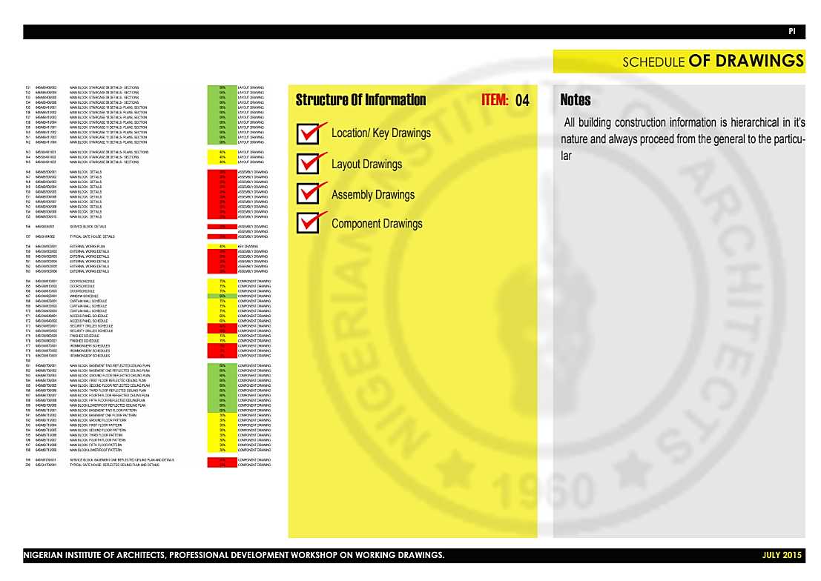

Source: Arc Sola Ige – NIA Professional Development Workshop on Working Drawings (2015).

**Fig 17:** Example of a schedule of drawing checklist for an architectural working drawing.

**3.2.8 Room Finish Schedule and Finish Schedule.**

An architectural working drawing's components are listed in alphabetical order by type in a Finish Schedule, starting with Acoustic Ceiling Tile and concluding with Paint. The standard sign used to identify these product groups is an abbreviation. Paint is frequently referred to as P and acoustic ceiling tile as ACT. If you have two types of paint, you will have P-1 and P-2. Construction teams utilize finish timelines to calculate costs and material requirements. The finish schedule serves as a hub for keeping track of completion tags. Construction papers like elevations and finish drawings are then given finish tags. The construction drawings and the three-part specification primarily communicate at this phase.

Track of any missing requirements can be done by using the finishing schedule as a checklist. A wall foundation, for instance, is essential even if it may not be the most eye-catching material to choose. A professional can recall the details while making material selections by using a finishing schedule. A finishing schedule includes a list of the supplies for flooring, walls, and roofing. Each of the condensed symbols is used in a room finish schedule to indicate where a product fits within the overall framework. It shows the name and number of the room in relation to the floor, the base of the walls, the north walls, the east walls, the south walls, the west walls, and the ceiling.

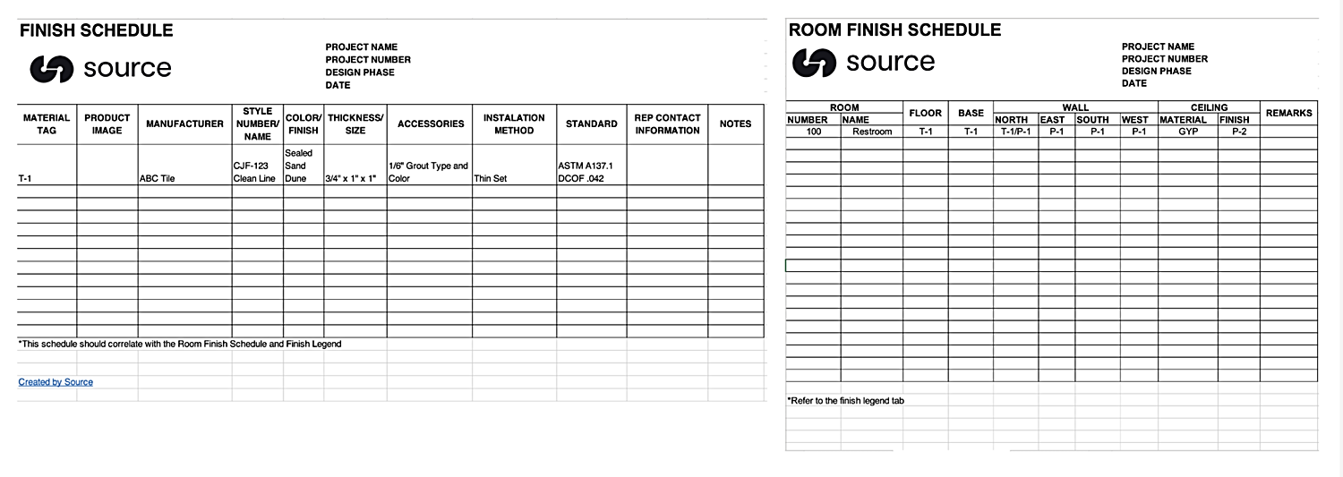

Source: tothesource.com

**Fig 18:** Example of a room finish schedule for an architectural working drawing.



Source: tothesource.com

**Fig 19:** Example of a finish schedule for an architectural working drawing.

**3.2.9 Door and Window Schedule**

Schedules for doors and windows are arranged supplemental information that is usually included in tables and goes beyond the information available in the building plans. The building plans would be packed with notes and hard to read if all the information in schedules was included on the drawings. The diverse types of windows and doors to be used in a building, their locations, and the hardware and finishes to be used with each of them are all listed in window and door schedules. (There are frequently separate hardware and finish schedules as well as fixtures and equipment schedules.) These schedules provide the additional information a contractor will need to install these items. Commercial and residential door schedules are similar in their fundamental patterns. The main distinction is that commercial door schedules are often lengthier and more comprehensive due to the complexity of major commercial projects and the requirements of local building codes. They are more likely to specify things like the door's fire rating and thickness, as well as conditions like the necessity that a door always be left open for safety.

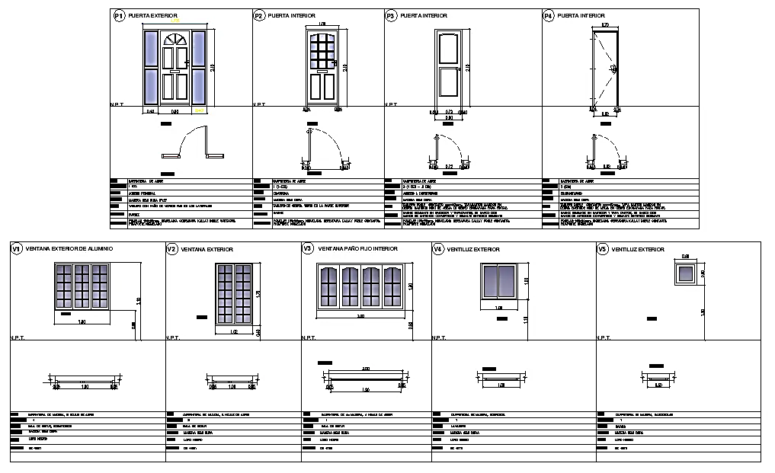

Source: tothesource.com

**Fig 20:** Example of a finish schedule for an architectural working drawing.

An architect readily cross-reference the papers since the first column on this and most schedules will have a number that matches one on the blueprints. On designs, doors are frequently denoted by a number in a hexagon, but windows are frequently denoted by a letter in a circle or diamond. The contractor can identify the type of door, its size, if any glass parts will be tempered, the door hardware, material, finish, and any other comments after locating the number for that door on the associated schedule. The fact that all French and sliding doors will be standard, not bespoke, as well as the fact that screens will be included with the sliding doors are both included in the timetable. Some schedules will also provide an estimate of the time and/or cost required to install each window and door. This information is useful for determining the project's overall cost and then adhering to a budget.

## 3.3 Key Principles of an Architectural Working Drawing.

The principles of an architectural working drawing include accuracy, clarity, conformance to codes and regulations, compatibility with construction methods and materials, dimensioning and scaling, lettering and notation, and line quality and style (Wong & Yeung, 2020). Important things to note are: accuracy and precision, clarity and consistency, conformance to codes and regulations, compatibility with construction methods and materials, dimensioning and scaling, lettering, font style and notation, line quality and style.

## 3.4 Tools and Techniques for an architectural working drawing

Traditional and electronic methods

The development of an architectural working drawing is a complex process that requires a deep understanding of the principles of drafting, geometry, and spatial relationships. Various techniques and tools for drafting which include the 2D and 3D computer-aided design (CAD) software, freehand drawing, sketching, and modeling. (Jia et al., 2020) states that “the choice of the right technique and tool depends on various factors such as the complexity of the project, the experience of the designer and the available resources”. Despite the critical role of working drawings in the architectural design process, there is a lack of comprehensive and up-to-date literature that systematically reviews the key concepts, principles, and techniques involved in working drawing. Studies already conducted frequently concentrate on certain elements of working drawings, such as the application of Building Information Modeling (BIM) or the function of the architect in the building process. (Chou et al., 2016; Abbasnejad et al., 2020). The traditional method involved hand sketching on tracing paper with ink or pencil. This was the only approach that was obtainable until recently. This fundamental drawing approach needs a precise table and continual attention to the tool placement. Allowing the triangles to slightly lower the top of the T-square, violating all angles, is a typical mistake. Drafting may be a time-consuming procedure, even for basic tasks like sketching two angled lines that meet at a point. This is because the T-square and triangles must be moved about a lot (Goetsch, 2000).

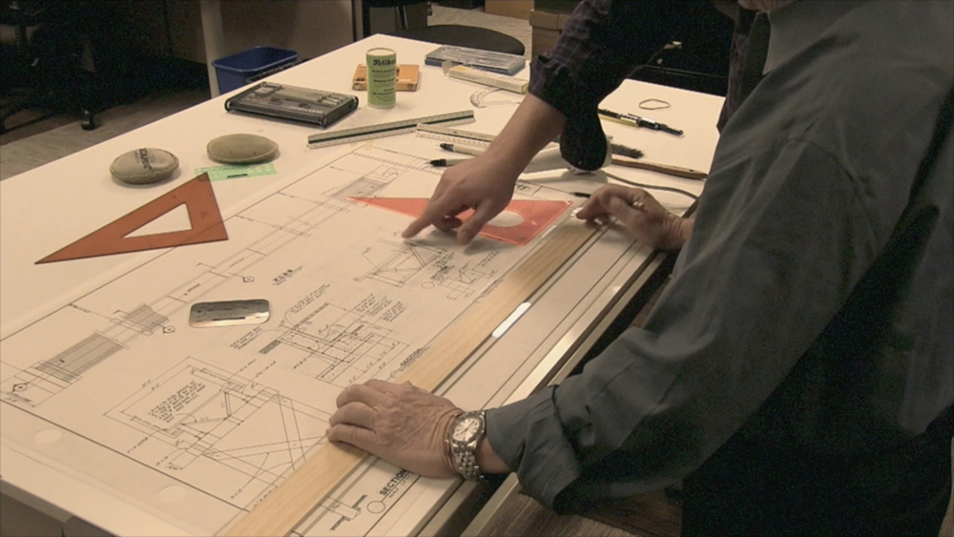

Source: Walter Ciridon (2015).

**Fig 21:** Example of an architectural drawing produced by a traditional method.

**Electronic Method:** This involves drawing them electronically on a computer screen utilizing a mouse to electronically draw them on a computer screen, then printing the output. AutoCAD and MicroStation are examples of 2D CAD programs that have replaced paper drawing. The software generates the curves, circles, arcs, and lines. The user's technical drawing ability will determine how well the drawing turns out. The technical drawing is created using user-defined views of the part geometry, which is initially created by a 3D CAD system. The program may produce any orthographic, projected, or sectioned view. This is computer-aided drawing (CAD), which is used by practically all architecture firms nowadays. Autocad, Revit, Archicad, Sketchup, 3D Home Architect, 3D Max, Chiefarchitect, Allplan, Vector works, Bentley Microstation, Digital Project, and other programs were utilized (Jefferis, 2005).

Traditional tools such as pencils, inks, rulers, papers, tracing sheets and T-squares are still commonly used in architectural working drawing, but computer-aided design (CAD) software, building information modelling (BIM) software, virtual reality (VR) and augmented reality (AR) technology, and 3D printing and prototyping are becoming increasingly popular (Khan & Nasir, 2020). Some software used for working drawings production includes Autocad, Revit, Archicad, and Sketch up.

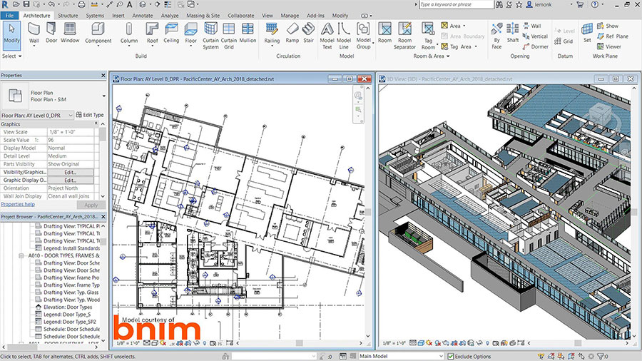

Source: Art Land Design studio (2019).

**Fig 22:** Example of an architectural drawing produced by an electronic method.

Working architectural drawings have been significantly impacted by technological advancements, which have given architects new tools to improve the accuracy and effectiveness of their work. In the world of architecture, these technical developments have improved design, teamwork, and communication. Another technology that has a big influence on architectural working drawings is cloud computing. Cloud-based solutions enable remote collaboration and minimize the requirement for physical document storage by enabling architects to save and view their designs from any location with an internet connection (American Society of Civil Engineers, 2018). Additionally, cloud computing enables architects to analyze huge and complicated models using powerful computing resources, enhancing the efficiency and precision of their work (Khalfan et al., 2015).

Despite the numerous advantages of technology in architectural working drawings, there may also be negative effects to take into account. For instance, a reliance on technology may result in the loss of manual drawing skills and conventional drafting abilities (Jankowski & Abidin, 2019). For smaller businesses or individual architects, the expense of using cutting-edge technology might also be a barrier (Chen et al., 2017). Therefore, the development of technology has had a tremendous influence on working architectural drawings, giving architects new tools to improve their job. Stakeholders may now generate and maintain digital representations of a building's physical and functional attributes because to advancements in design, cooperation, and communication. However, possible disadvantages including a loss of conventional drafting abilities and financial issues must also be taken into account.

**3.5 Standard Symbols, Abbreviations and Symbols Application in an Architectural Working Drawing.**

There isn't much room to work with while creating architectural working drawings. This implies that architects must make the most of the available area. In order to avoid confusion, a variety of symbols, abbreviations, and acronyms are employed on documents and drawings (Betts, 2020). Various doors have different symbols based on their hinges, opening orientation, number of doors, opening and closing mechanism, etc. The same holds true for various types of windows. A few typical forms are double-hung, single-hung, right sash over left, left sash over right, etc., and each has a distinctive symbol (Vasquez, 2022). To ensure that everyone involved has a common understanding of the designs, floor plan symbols serve as their own language. The following standard symbols are prevalent: wall symbols, roof drain, callout, details, room labels, door, window, section line, elevation, north arrow, etc. (BigRentz, 2023). Different building businesses or specializations may have subtle changes.

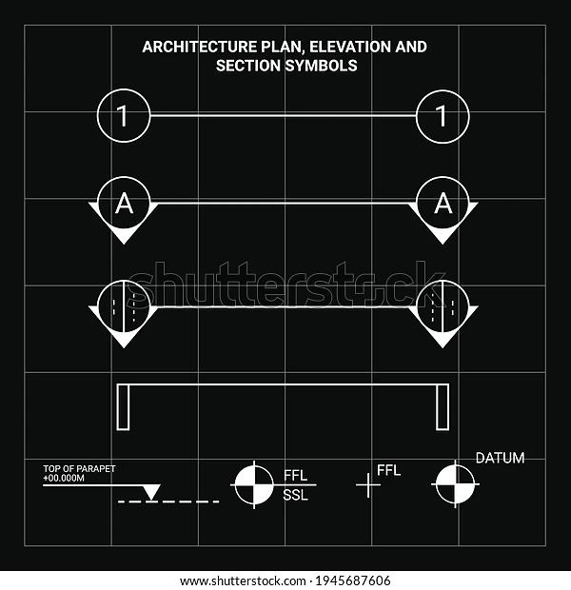

Source: Axwara // Shutterstock <https://www.shutterstock.com/image-vector/architectural-drawing-symbol-plan-elevation-section-1945687606>

**Fig 23:** Example of the symbols used in architectural working drawings.

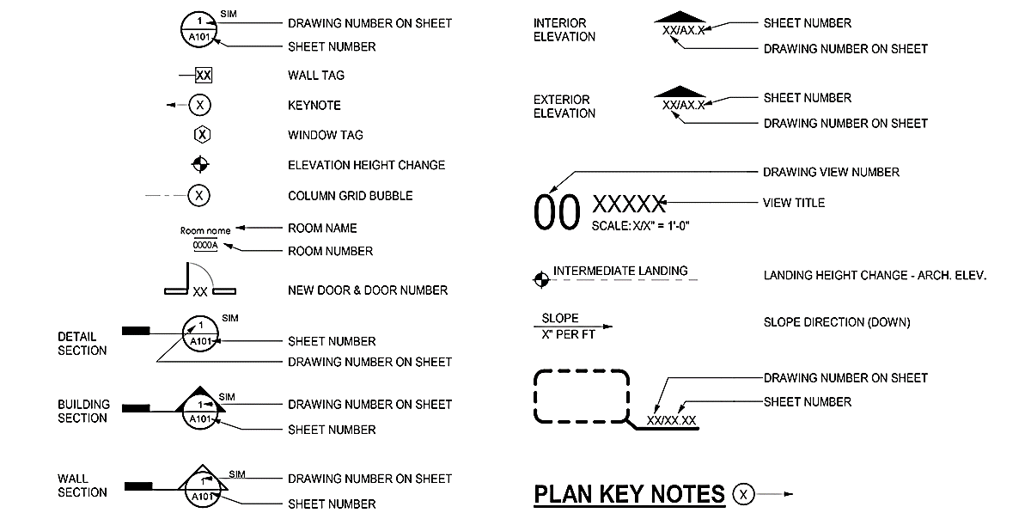

Source: Bob Borson (2021)

**Fig 24:** Example of the symbols used in architectural working drawings.

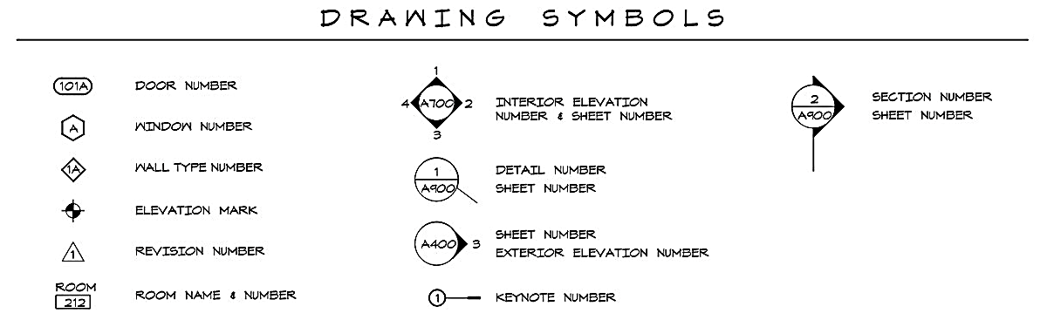

Source: Bob Borson (2021)

**Fig 25:** Example of the symbols used in architectural working drawings.

**Table** 1**:** Some Architectural Working Drawing Abbreviations

|  |  |  |
| --- | --- | --- |
| S/N | Abbreviations | Meaning |
| 1 | AFF | Above Finished Floor |
| 2 | AFG | Above Finished Grade |
| 3 | BOF | Bottom of Footing |
| 4 | BOW | Bottom of Wall |
| 5 | BP or B/P | Blueprint |
| 6 | CAD | Computer-Aided Drafting |
| 7 | DWG | Drawing |
| 8 | Exc | Excavate |
| 9 | FAO | Finish All Over |
| 10 | FFL | Finished Floor Level |
| 11 | FL | Floor Level |
| 12 | FRPF | Fireproof |
| 13 | GC | General Contractor |
| 14 | IE | Invert Elevation |
| 15 | HV | High Voltage |
| 16 | IAW | In Accordance With |
| 17 | LDD | Limited Dimension Drawing |
| 18 | Jst | Joist |
| 19 | MFG | Manufacturing |
| 20 | NIC | Not in Contract |
| 21 | PL | Property Line |
| 22 | REBAR | Reinforcing Bar |
| 23 | REQD | Required |
| 24 | Reinf | Reinforced |
| 25 | San | Sanitary |
| 26 | TOB | Top of Beam |
| 27 | TOC | Top of Curb or Top Of Concrete |
| 28 | TOF | Top of Footing |
| 29 | TOJ | Top of Joist |
| 30 | TOM | Top of Masonry |
| 31 | TOW | Top of Wall |
| 32 | VA | Voltage |
| 33 | WL | Water Level |

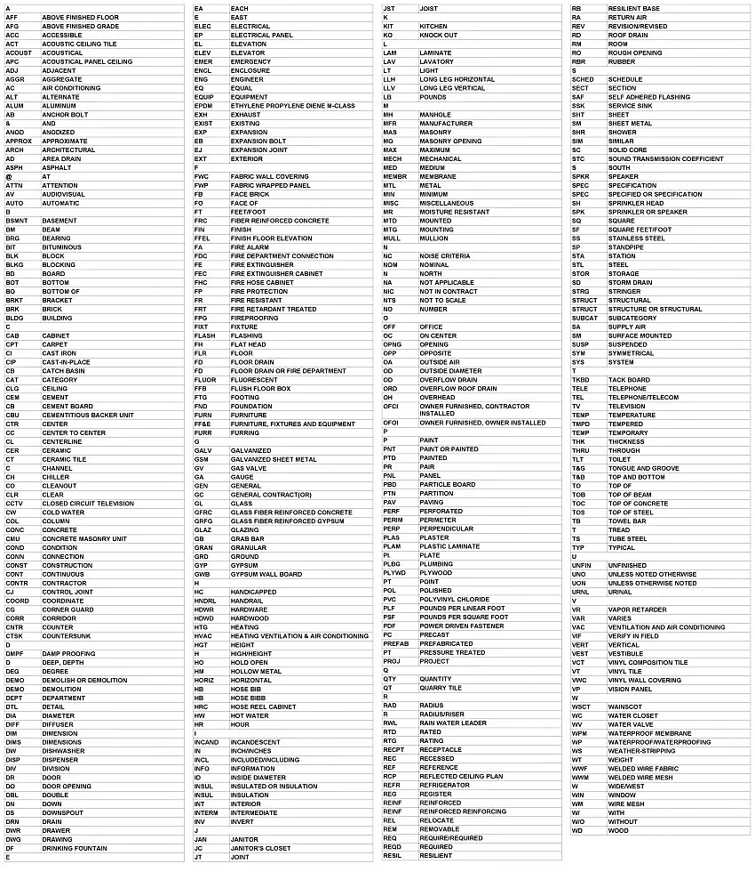

Source: <https://bimsquare.com/product/revit-architectural-abbreviations/>

**Fig 26**: A list of the abbreviations used in architectural working drawings.

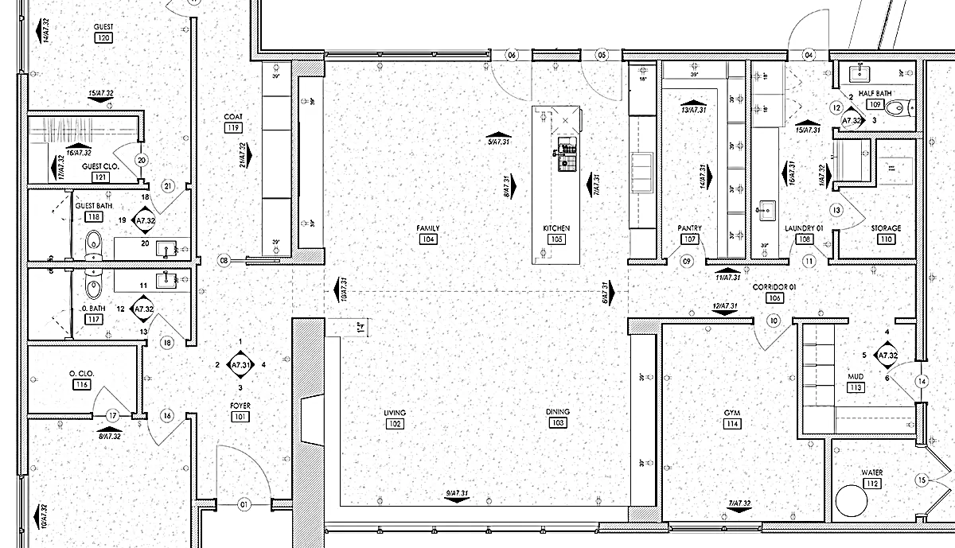

Source: Bob Borson (2021)

**Fig 27:** Example of a floor plan with the application of the symbols.

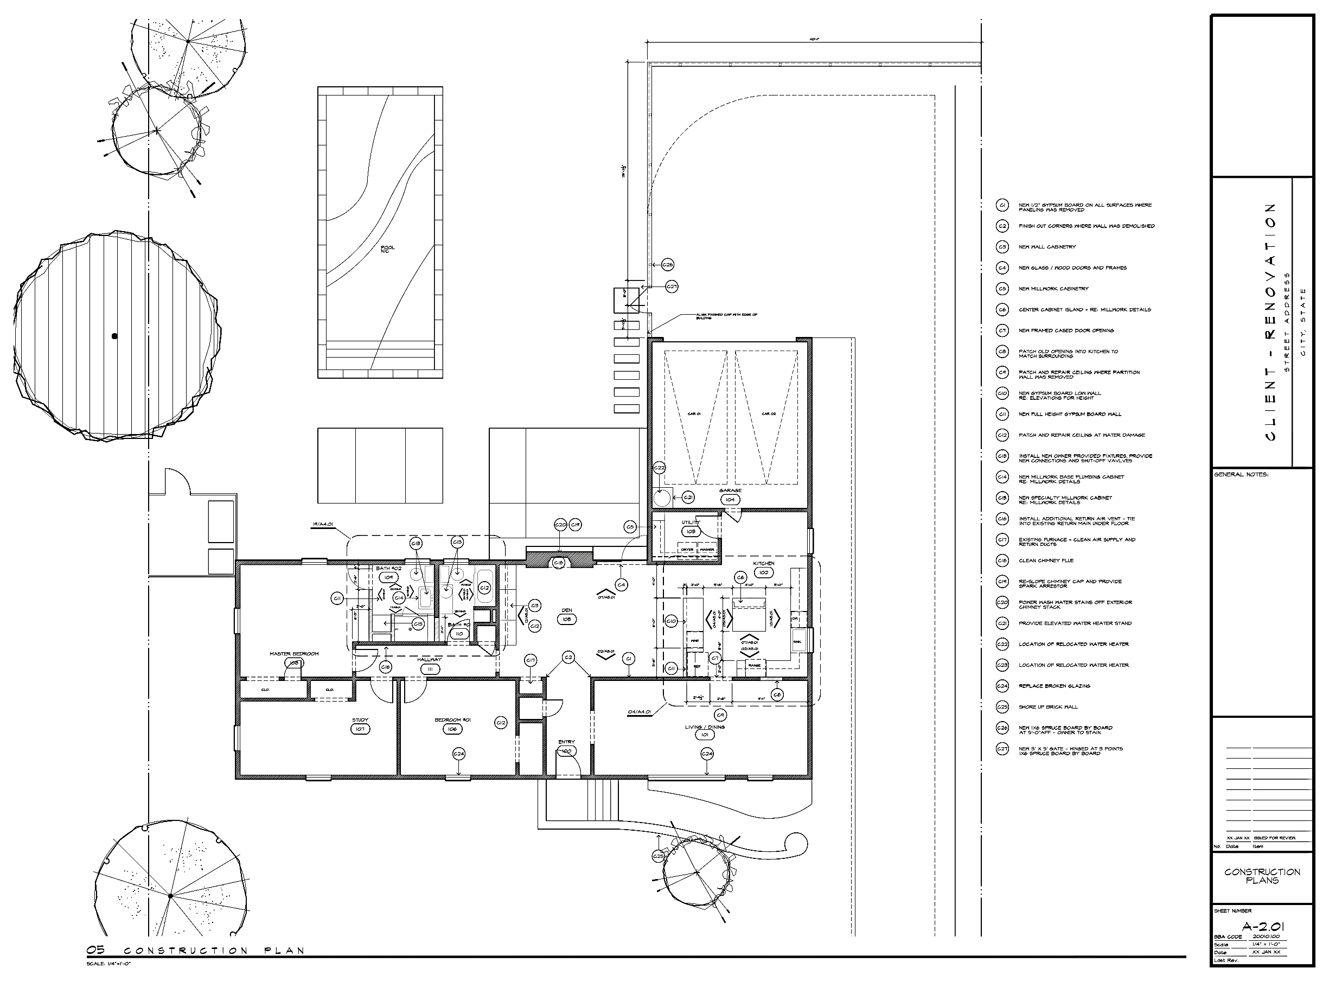

Source: Bob Borson (2021)

**Fig 28:** Example of a floor plan with the application of the symbols.

## 3.6 Challenges, limitation, and Opportunities of an architectural working drawing

Despite the importance of architectural working drawing, several challenges and opportunities exist in the field. One major challenge is the lack of standardization in the industry, leading to confusion and errors in construction. Another challenge is the lack of attention given to the quality of architectural working drawing, leading to cost overruns and delays in construction. However, advances in digital technology provide opportunities to improve the quality and efficiency of architectural working drawing. A precise and thorough plan for building construction is provided by architectural working drawings, which are a crucial component of the construction process. However, there may be a number of difficulties in the preparation and interpretation of these drawings, which might have an effect on how well a building project goes. The systems that support the functioning of modern buildings, such as the heating, ventilation, and air conditioning (HVAC), electrical, and plumbing systems, are getting more and more sophisticated. It can be difficult to accurately depict such intricate architectural systems in working drawings (Chen et al., 2017).

Challenges in an architectural working drawing include the impact of globalization on design standards and the need for standardization and interoperability in an architectural working drawing (Pan & Wang, 2019). Opportunities in architectural working drawing include the potential of emerging technologies such as BIM and VR to transform the design and construction process (Wong & Yeung, 2020). Several studies have highlighted the challenges and opportunities in the field of architectural working drawing. According to a study by Awwad and Aboelmaged (2018), the lack of standardization in the industry is a significant challenge that affects the accuracy and consistency of architectural working drawings. The study emphasized the need for standardization of symbols, notations, and drawing conventions to improve the clarity and accuracy of the drawings.

Another study by Akintoye et al. (2002) identified poor communication and coordination among project team members as a challenge in the creation and utilization of architectural working drawings. This challenge leads to errors, conflicts, and delays in the construction process. In terms of opportunities, digital technology has brought significant advancements in the field of architectural working drawing. Building information modeling (BIM), according to research by Wu and Wu (2017), has transformed the production and usage of architectural working drawings. BIM makes it possible to create intricate 3D models that may be utilized to produce precise and well-organized construction papers. This technology improves the quality and efficiency of architectural working drawing, reducing errors and delays in construction.

Overall, the challenges and opportunities in the field of architectural working drawing demonstrate the need for ongoing research and development to improve the quality, consistency, and efficiency of these drawings.

## 3.7 Best Practices in Architectural Working Drawing:

Several best practices have been identified for creating effective architectural working drawings. These include creating clear and concise drawings, using standardized symbols and notations, providing detailed and accurate dimensions, and ensuring the drawings are compatible with other construction documents. Architectural working drawings play a crucial role in the construction process, and creating effective drawings is essential to ensure that construction projects are executed efficiently and accurately. Several best practices that have been identified in creating effective architectural working drawings, as highlighted by various researchers are discussed in this study.

One of the most important aspects of creating effective architectural working drawings is to ensure that they are clear and concise. According to the American Institute of Architects (AIA), architectural drawings should be clear and easily understood by those who use them, regardless of their level of technical expertise (AIA, 2014). Another important best practice is the use of standardized symbols and notations. Standardization of symbols and notations across several types of drawings, such as floor plans and elevations, facilitates effective communication among architects, builders, and other stakeholders (Sacks et al., 2010). Providing detailed and accurate dimensions is another critical best practice in creating effective architectural working drawings.

According to the Construction Specifications Institute (CSI), dimensions should be clear, accurate, and consistent throughout the drawings, with all dimensions given in the same units (CSI, 2018). Ensuring that the drawings are compatible with other construction documents is also essential. This includes ensuring that the drawings are coordinated with other construction documents, such as specifications and schedules (AIA, 2014). Additionally, it is important to ensure that the drawings are compatible with digital tools used for construction project management, such as Building Information Modeling (BIM) (Kim and Lee, 2019). Overall, following best practices in creating architectural working drawings can help ensure that construction projects are executed efficiently, accurately, and with minimal errors and delays.

# 4. Discussion

The literature review revealed several key concepts and themes related to the fundamentals of architectural working drawing. importance and key purposes/uses of an architectural working drawing, types and checklists of key architectural working drawings, key concepts and principles of an architectural working drawing, tools and techniques for an architectural working drawing, minimum and standard requirements of an architectural working drawing, standard symbols, abbreviations, and schedules’ practical applications in an architectural working drawing, challenges, limitations, and opportunities of architectural working drawings, and best practices for an architectural working drawing. The literature review found that architectural working drawing is a critical aspect of the design and construction process for building projects, and its importance cannot be overstated. With the advent of digital technology in the 20th century, the process of creating architectural drawings became more efficient, accurate, and accessible.

The purpose of architectural working drawing is to communicate design intent, specify construction details, and facilitate construction coordination, therefore, the quality of architectural working drawing has a significant impact on the construction process's efficiency, cost, and quality. The review identified several types of architectural working drawings, including floor plans, elevations, sections, details, schedules, and specifications. Each type serves a specific purpose, and the level of detail and scale can vary depending on the project's requirements. Best practices for creating effective architectural working drawings include creating clear and concise drawings, using standardized symbols and notations, providing detailed and accurate dimensions, and ensuring the drawings are compatible with other construction documents. Several challenges and opportunities were identified in the field of architectural working drawing. They include the lack of standardization in the industry, the lack of attention given to the quality of architectural working drawing, and the excessive cost of producing high-quality drawings are significant challenges. However, advances in digital technology provide opportunities to improve the quality and efficiency of architectural working drawing.

# 5. Conclusion

The study aimed to address the gap in knowledge by providing a comprehensive overview of the fundamentals of architectural working drawing. Specifically, the review will explore the following research questions:

i. What are the importance and key purposes/uses of an architectural working drawing?

ii. What are the types and standard requirements of key architectural working drawings?

iii. What are the key concepts and principles of an architectural working drawing?

iv. What are the tools and techniques for an architectural working drawing?

v. What are the standard symbols, abbreviations, and symbols application in an architectural working drawing?

vi. What are the challenges, limitations, and opportunities of architectural working drawings?

vii. What are the best practices in architectural working drawing?

Based on the findings of this literature review, the following recommendations are suggested for improving the quality and efficiency of architectural working drawing:

1. Standardization: The lack of standardization in the industry is a major challenge that needs to be addressed. Standardized symbols, notations, and formats should be adopted to improve communication and reduce errors in construction.
2. Training: Adequate training should be provided to architects and builders on creating and interpreting architectural working drawings. This will improve the quality and accuracy of the drawings, leading to a more efficient construction process.
3. Quality Control: Quality control measures should be implemented to ensure that the drawings are accurate, complete, and compatible with other construction documents. This will prevent errors, delays, and cost overruns in construction.
4. Technology: Digital technology may be used to enhance the effectiveness and caliber of architectural working drawings. Building information modeling (BIM) adoption may enhance stakeholder coordination and cooperation while lowering construction mistake rates.

Also, importance should be placed on the impact of globalization on an architectural working drawing, the need for standardization and interoperability in an architectural working drawing, the role of sustainability and green design in an architectural working drawing, the potential of emerging technologies to transform an architectural working drawing, the importance of collaboration and communication in an architectural working drawing. Therefore, to improve the effectiveness and accuracy of architectural working drawings, further study is recommended. This would help to properly examine the possibilities of new technologies like artificial intelligence and machine learning.

# References

Brahmi, F., & Sidawi, B. (2017). Importance of Working Drawings in Construction. International Journal of Scientific & Engineering Research, 8(10), 1307-1313.

Brahmi, F., & Sidawi, B. (2017). Importance of Working Drawings in Construction. International Journal of Scientific & Engineering Research, 8(10), 1307-1313.

Browning, W. (2018). Architectural working drawings: A practical guide for architects and builders. Routledge.

CASP (n.d.). Critical Appraisal Skills Programme (CASP) Checklists. Retrieved from https://casp-uk.net/casp-tools-checklists/

Cedreo. (2022). *Roof Plan Fundamentals: How to Save Time on Detailed Plans for Contractors and Clients*. https://cedreo.com/blog/roof-fundamentals/

Chen, Y., & Wang, L. (2020). A review of BIM-based construction quality control. Journal of Cleaner Production, 260, 121075.

Ching, F. D. K. (2014). Architecture: Form, space, and order. John Wiley & Sons.

Designing Buildings Wiki. (2020). *Schedule of drawings* [Definition; Guidance; Template]. https://www.designingbuildings.co.uk. https://www.designingbuildings.co.uk/wiki/Schedule_of_drawings

Designing Buildings Wiki. (2023). *Elevations* [Definition; Guidance; Standard]. https://www.designingbuildings.co.uk. https://www.designingbuildings.co.uk/wiki/Elevations

Edraw Content Team. (n.d.). *Reflected Ceiling Plan: The Complete Guide | EdrawMax*. Edrawsoft. Retrieved 17 April 2023, from https://www.edrawsoft.com/reflectedceiling-design-guide.html

Hesson, R. (2023, March 2). *Reflected Ceiling Plans—Construction Drawings*. Northern Architecture. https://www.northernarchitecture.us/construction-drawings/r.html

Holt, C. (2012). Architectural Graphics Standards for Architects, Engineers, Decorators, Builders and Draftsmen. John Wiley & Sons.

Ige, S. (2018). *Working Drawings Checklists*. https://www.slideshare.net/SolaIge/working-drawings-checklists

Kim, H. S., & Choi, M. J. (2015). The impact of computer-aided design (CAD) on architectural design and drawing in South Korea. Architectural Engineering and Design Management, 11(2), 118-129.

Lin, T. Y., & Chang, T. Y. (2010). Computer-aided design history: A reflection on functional beauty. Design Principles and Practices: An International Journal, 4(6), 159-168.

Mahgoub, Y. O. M. (2020, April 2). *Architectural and Technical Detailing—Reflected Ceiling Plan—False Ceiling Details by Yasser Osman Moharam Mahgoub—Issuu*. https://issuu.com/ymahgoub/docs/architectural_and_technical_detailing_-_reflected_

Malek, M. R. (2020). Architectural working drawings: A guide to their development and use. Routledge.

MasterClass. (2022). *Interior Design 101: Elevation Drawings and Floor Plans - 2023*. MasterClass. https://www.masterclass.com/articles/interior-design-101-elevation-drawings-and-floor-plans

Pan, W., & Wang, S. (2019). Interoperability of Architectural Drawing Standards: A Review. Journal of Information Technology in Construction, 24, 378-394.

Sang, J., Kim, K., & Kim, H. (2020). A review of the role of artificial intelligence in construction management. Automation in Construction, 117, 103221.

Smith, J. (2020). *What is a Reflected Ceiling Plan? | 2020*. MT Copeland. https://mtcopeland.com/blog/what-is-a-reflected-ceiling-plan/

Tachie, P. B., Adinyira, E., & Oduro-Frimpong, J. (2016). The role of architectural working drawings in the construction industry. Journal of Engineering and Applied Sciences, 11(9), 1961-1965

Khan, M. A., & Nasir, S. (2020). Architectural Drawings: Traditional Tools and Techniques vs. CAD and BIM. Journal of Architecture and Civil Engineering, 3(3), 31-44.

Khan, K. S., Kunz, R., Kleijnen, J., & Antes, G. (2020). Five steps to conducting a systematic review. Journal of the Royal Society of Medicine, 96(3), 118-121. doi: 10.1177/0141076820902062

Kulkarni, P., & Khedkar, U. (2016). Architectural working drawings: a review. International Journal of Engineering Research and General Science, 4(3), 23-29.

Kumar, V., Bharti, N., Rana, N. P., & Singh, R. (2019). A Literature Review on Types of Architectural Drawings. Journal of Engineering and Applied Sciences, 14(9), 3038-3043.

Kwok, A. G., & Grondzik, W. T. (2014). The green studio handbook: environmental strategies for schematic design. Routledge.

Li, S., Shen, G. Q., Wu, P., & Chen, Y. (2018). Investigating the impact of BIM on architectural design and construction. Journal of Cleaner Production, 172, 2232-2248.

Osman, H. (2018). Study on the importance of working drawings in construction projects. IOP Conference Series: Materials Science and Engineering, 365(1), 012053. https://doi.org/10.1088/1757-899x/365/1/012053

Ozelton, E. C. (2000). The construction industry: The challenge ahead. Construction Management and Economics, 18(7), 785-794.

Wong, J. K. W., & Yeung, J. F. Y. (2020). A Review of Building Information Modeling (BIM) Applications in Architecture. Applied Sciences, 10(13), 4469.

Wong, K. W., & Wong, K. P. (2014). An overview of the types of architectural drawings. In Handbook of Research on Building Information Modeling and Construction Informatics: Concepts and Technologies (pp. 136-159). IGI Global.

Zhou, Y., Chan, A. P., & Zhang, X. (2017). Investigating the critical success factors for BIM implementation in China. International Journal of Construction Management, 17(1), 1-16.